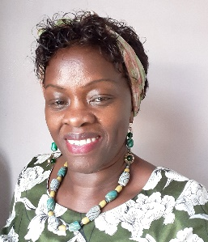

Angelina Jalonen

Head of Therapeutic Services - Refugee Council.

Angelina draws on her extensive experience of working in the voluntary sector to develop and deliver specialised psychosocial programmes to promote the wellbeing of Asylum Seekers and Refugees.

Angelina is a qualified Psychological Therapist who also holds a Masters in Refugee Care. She is a Therapeutic Supervisor and a registered member of the British Association of Counselling and Psychotherapists.(BACP). She is a trainer on topics related to mental health and best practice working with Refugee population. She is a guest lecturer on the psychological programmes at some Universities.

Angelina is the Head of Therapeutic Services at the Refugee Council based in London and across the regions. She takes a leading role in developing and implementing trauma informed projects to respond to asylum seekers and refugees presenting with mental health issues including PTSD and Complex PTSD.

Her special interest focus on all dimensions of Refugee trauma, inter-cultural psychology, social justice and human rights. Her work is further informed by understanding psychosocial perspectives in forced migration, refugee voices and the power of bearing witness.

She has co-authored in a practical guide to *“Therapeutic Work with Asylum Seekers and Refugees*” and also contributed in the Volume “Oxford *Textbook of Migrant Psychiatry”*

Angelina is involved in international work in a range of capacities including empowering women groups. She is the founder of Rafikihome.org a children’s home in Kenya which is based on compassion and stability and applies a foster care approach to facilitate positive transformation and give hope to a better life.