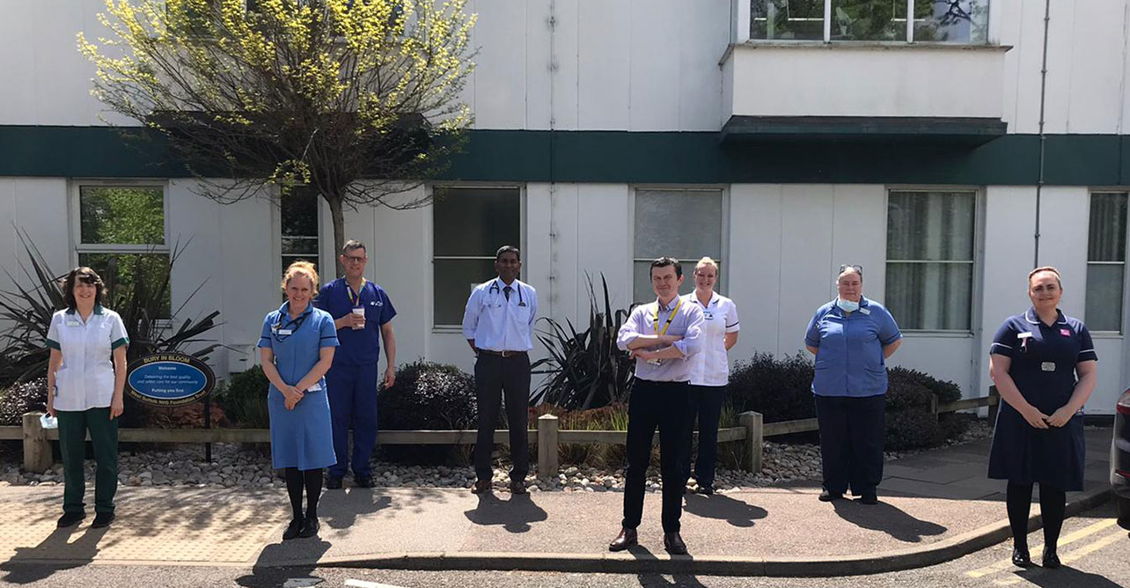

Biography of Hip Fracture Team West Suffolk Hospital

Mr Konrad Wronka – lead orthopaedic surgeon for hip fractures. Consultant Trauma and Orthopaedic appointed in 2019, specialising in Hip and Revision Hip arthroplasty with interest in peri prosthetic fracture management. Very dedicated to improving outcomes of injuries of frail patients, theatre efficiency and trauma service provision. Strongly believing in marginal gains theory.
Konrad is very enthusiastic in helping the Trust maintain its reputation with hip fractures. Quiet, and fast he is an advocate of leading from the front, letting staff see that he is as hard-working as he is polite.

Dr Mohanraj Suresh – has been our lead orthogeriatric consultant since appointment in 2011. He believes in hitting the ground running, and it has been noticeable how the NHFD figures improved soon after his appointment. Well-known in theatres for chasing up any potential delay with the reputation of a pit-bull with jaws of steel, and a formidable style of doing the job himself.
Dr Jonathan Nicholson – lead anaesthetist with the hip fracture team. He has been doing it for so long now, that even when he felt he should step down to allow young blood in, no-one dared to take on such big shoes. After a couple of bouts of long-term sickness, he is back with us to stay and cement his credentials on the anaesthetic pathways for good.
Nikki Smith – orthopaedic therapy team leader. She loves to give all patients the opportunity to progress easily with mobility and independence following surgery. She has done a huge amount of work to help sort out our 1st day mobilisation issues.
Trixie Douglas – trauma nurse practitioner. She trained at the glorious WSH, qualifying in 1985, and has been a trauma practitioner for 11 years now. Well-known for correcting doctors in the vernacular of the West Suffolk Way, she will take no prisoners or cut any corners to get the patients processed efficiently and safely.

