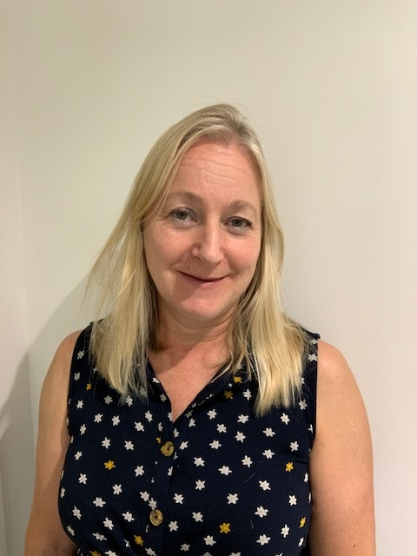Information for Caldicott Guardian Course 6/12/2022

Biography

Dr Sarah Aylett is a Consultant Paediatric Neurologist and the Caldicott Guardian at Great Ormond Street Hospital. She has an interest involving young people in their access to and the use of their health data. Sarah works closely with the Medical Records Team, Information Governance and the Research Governance Teams to uphold confidentiality and to ensure access to health data where appropriate.

Abstract

There are challenges and opportunities of the role of the Caldicott Guardian in a tertiary children’s hospital which has fully electronic records. It is important to ensure young people (YP) are involved in the use of their personal data whilst considering their competency and the legal framework. Medical records may contain information about third parties, as well as that of the child which in addition needs to be considered in relation to confidentiality, for example, third party genetic or psychiatric information. Police requests for medical records typically involve cases of infants or children who have been subject to physical abuse which need to be scrutinised before release. EPR has brings great benefits to the service but also brings challenges in ensuring data breaches do not occur. In the environment of data sharing in the NHS, National Audits and the option to opt out of data being included, there are increasing complexities in health data use.