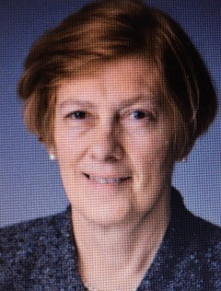
Maire Morton
I am a consultant Oral & Maxillofacial surgeon based at East Lancashire NHS trust. I did my undergraduate training in London at Guys Hospital and later worked in Sheffield and Aberdeen before joining the training programme in the North West. During my training I spent time in the USA on the programme in Texas at Parkland Memorial and Fort Worth both leading orthognathic units at that time. Later I also spent time with Prof Stoelinga in the Netherlands. In 1987 I was appointed consultant at the Royal Blackburn Hospital. During my time there the unit became the centre for OMFS services from Bolton, Bury and Burnley. I also worked with the Manchester Cleft Lip and Palate Unit.
I was very involved in management being divisional director for Surgery and Anaesthetics for 5 years. I joined the GIRFT team in 2016 as the clinical lead for OMFS and in 2021 became the OMFS lead with NCIP
I was elected to BAOMS council and became president in 2010

