Biography
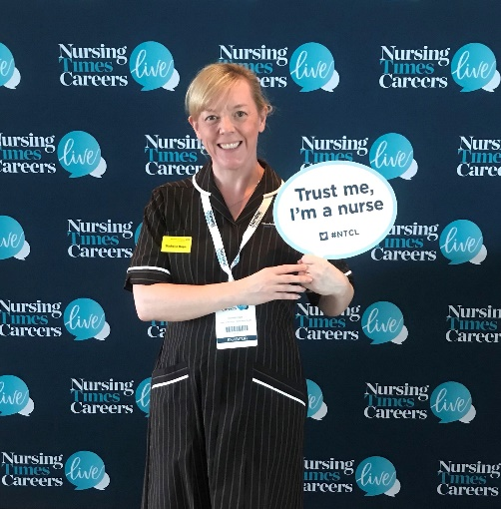
Michelle is Registered Nurse with clinical expertise in haematology & oncology she has since moved into senior operational and corporate roles developing her leadership skills within both the NHS and the private sector. As a Darzi Fellow alumnus she is passionate about high quality patient care and has experience as a specialist advisor to the CQC as well as gaining a QSIR practitioner qualification to build upon the QI skills gained during her time as a Darzi Fellow.
Michelle is a caring, approachable, and authentic leader who uses her initiative to motivate and inspire others, utilising the knowledge & skills gained during her clinical and professional leadership experience to ensure that both staff and patient experience is of a high quality.
Michelle is proud to have double Masters qualifications with an MSc in Advanced Practice (leadership) & an MBA in Health & Social Care. She is also currently a student researcher at Anglia Ruskin University on the DProf Health & Social Care programme.
Michelle had a personal contribution in the design, pilot and rollout of a ward accreditation programme at a London NHS Trust & was intrigued to discover if the concept does in fact improve patient care. This was the basis of her MBA dissertation in which she undertook a piece of secondary research.
Michelle is currently Deputy Chief Nurse at West Hertfordshire Teaching Hospitals NHS Trust.
The Abstract

Ward Accreditation as an assurance tool for quality.
• ward accreditation explained
What is it and what is it intended to achieve?
Why am I interested in it?
• encouraging ownership of continuous quality improvement at ward level
Going for silver
Medal awards
• engaging and empowering staff to improve the basic standards and quality of care at ward
Level and reduce variation in standards between wards
CQC fundamentals of care 9 standards
• sharing best practice across wards
Peer review
• increasing staff pride within their ward areas
Going for gold
Key points

