Sarah Rae
Independent Expert by Experience

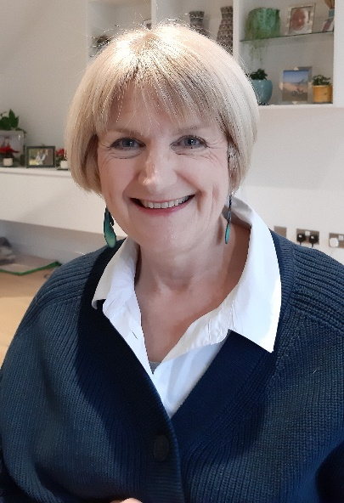

Sarah Rae has accessed mental health services on many occasions throughout her adult life. After a negative experience of acute care in 2005 she became determined to influence the design and delivery of services in her local mental health Trust. Sarah’s involvement with quality improvement initiatives led her to join the Health Foundation’s Q community in 2012.
She was a Non-Executive Director of the NIHR Applied Research Collaboration (ARC) East of England from 2011-2019 where her role was to champion Patient and Public Involvement (PPI). In addition, she has worked with the Eastern Academic Health Science Network on several mental health related projects and is a member of the East of England Citizens’ Senate.
Sarah joined Board of national Mind in 2011. Her responsibilities, as trustee for nine years, included overseeing the strategic and general management of the charity. Following the publication of Mind’s crisis care report, she co-founded PROMISE (Proactive Management of Integrated Services and Environments) in 2013. The impact of this three-year quality improvement programme was to significantly reduce the use of physical interventions within the Cambridgeshire and Peterborough Foundation Trust.
Since 2018 she has been a member of the APT Trial Steering Committee. The aim of this national research study is to test whether a new anti-inflammatory drug has the potential to treat patients suffering from major depression disorder and whose symptoms remain despite current medications.
Over the last two years Sarah has contributed, as a lay member, to the NICE Guideline Committee to assist with revising and updating the guidance on self-harm.
Sarah is currently the Patient and Public Involvement (PPI) Consultant for the Safety in Mental Health Settings project. This pan-London project is focused on addressing issues of violence and aggression within acute care and PICU. The aim is to strengthen safety culture within wards, to support staff skills development, and to improve staff recruitment and retention. The project is sponsored by the Cavendish Square Group of all London NHS mental health trusts and funded by NHS England/Improvement and Health Education England.
During the last four years she has also brought together an experienced team of academics and clinicians to develop a major new research study: ‘Coproducing improved mental health acute inpatient discharge using a Systems Approach: MINDS’ https://www.nsft.nhs.uk/minds-study This complex three-year NHIR project will apply a Systems Approach to co-design holistic discharge planning processes model for adult general acute mental health inpatient settings. The aim is to improve the outcomes and experiences for patients being discharged from mental health hospitals.
Sarah has been working as a member of the Ethnicity and Mental Health Improvement Project (EMHIP) Reference Group for over a year. EMHIP has been designed to be a practical, locality-based service improvement programme to bring about change for Black Minority Ethnic (BME) communities in mental health care. The aim of the programme is to reduce inequalities in three specific areas where Black, Asian and Minority Ethnic communities fare worse: in access, experience, and outcomes of mental health care.
In 2021 Sarah was appointed as the PPI co-lead on the NIHR ARC National Priorities in Mental Health programme where she is responsible for overseeing the PPI workstream and working closely with the programme’s ‘Mental Health Implementation Network’. The Network is a collaboration of experts by experience, local communities, health and care providers, commissioners, and a range of regional and national stakeholders, including charities and local government. It is led by NIHR ARC South London, working closely with NIHR ARC East of England, as well as the other 13 ARCs nationally.

