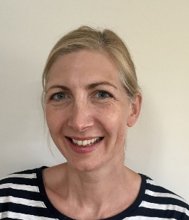

**Speaker Name: Michelle Stafford**

**Event:** Medication Errors Conference

Hc-uk.org.uk

Friday 21st October

Speaker Bio

Michelle Stafford is the Safety and Learning Lead for the South region, after joining NHS Resolution in 2020. She has been involved in developing the Medication Errors learning resources by NHS Resolution.

She holds a BSc (Hons) in Podiatric Medicine, a Master’s in Management and a Diploma in Diabetes Management in Primary Care.

She has held regional roles implementing national guidance and providing leadership in delivering best practice in patient care.  She is passionate about patient safety, and the importance of a just and learning culture within organisations.

**Abstract:**

Learning from claims to reduce medication error

* Increased understanding of claims data related to medication errors
* The key ambitions of the National Medication Safety Programme
* The most common medications involved in incidents
* Improving the safe use of anticoagulants
* Understanding of learning organisation principles and relationship to organisational culture
* Identify ways in which you might want to change your own policies, procedures or practice to support learning

|  |  |
| --- | --- |
| **Contact Information** | |
| Job Title: Michelle Stafford | Safety and Learning Lead - South |
| Company: NHS Resolution | NHS Resolution |
| Michelle.stafford5@nhs.net |  |