ABSTRACT

Learning from the National Analysis of Safeguarding Adults Reviews
The first national analysis of findings from SARs, published in 2020, identified what is working well in adult safeguarding and what requires improvement. This presentation will set out key features of that learning, and will report also on how the review process itself can be strengthened.

BIOGRAPHY

Suzy Braye, OBE, FAcSS
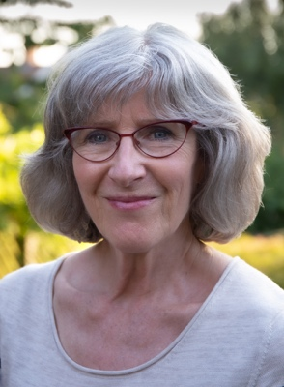

Practising now as a consultant and researcher in adult safeguarding, Suzy acts as an independent reviewer in safeguarding adult reviews and provides training and practice development workshops to local authorities, health trusts, CCGs and Safeguarding Adults Boards. She is a qualified social worker with a professional and management background in local authority social services and has also held training, research and management posts in higher education. Her research into self-neglect, conducted for the Department of Health & Social Care and carried out in partnership with Michael Preston-Shoot and David Orr, has been influential on the development of both national and local policy in self-neglect. She is a Fellow of the Academy of Social Sciences and in 2017 received an OBE in recognition of her contribution to the adult safeguarding field. In 2020, in partnership with Michael Preston-Shoot and Research in Practice, she undertook the first national analysis of learning from safeguarding adult reviews, commissioned by the LGA/ADASS Care & Health Improvement Programme.

