Michael Shenouda

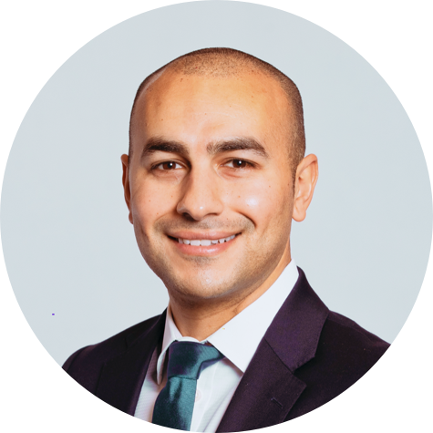

Michael Shenouda is a practicing orthopaedic surgeon and Medical Director at Open Medical. His roles include overseeing clinical pathway design, clinical risk and patient safety management, and stakeholder communication across a large healthcare network of both practicing clinicians and senior hospital management. He is currently furthering his academic studies with an Executive MBA.