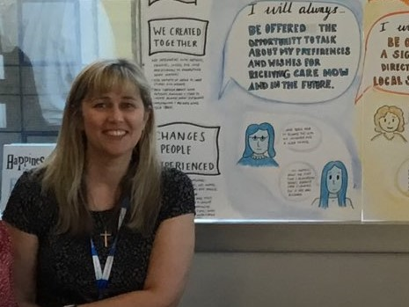Helen is a qualified nurse with experience of working in both acute and community settings and was Head of Quality Improvement and Experience in a provider organisation prior to her current role. Helen is Experience of Care Professional Lead with NHS England and NHS Improvement leading on co-production and the #AlwaysEvents ® programme. Always Events® are those aspects of care that are so important to people using services, their families and carers that they should always occur at every interaction with healthcare professionals and the health care delivery system (Institute for HealthCare Improvement).    Helen is passionate about people being at the heart of everything we do and co-producing improvements; Always Events® are a fantastic way to bring these to life.

E-mail: [helen.lee12@nhs.net](mailto:%20helen.lee12@nhs.net)

Twitter: @helenlee321_lee #ExpOfCare #AlwaysEvents

For more information on Always Events please see: <https://www.england.nhs.uk/always-events/>