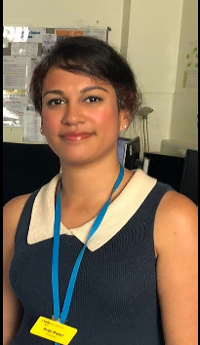**Biography- Priti Patel, Integrated Care Pharmacist, Guy`s and St. Thomas` NHS Foundation Trust**

Currently I am a Pharmacist working with older people in integrated care services at Guy`s and St. Thomas’ NHS Foundation Trust. I have worked in the NHS as a Clinical Pharmacist for nearly 15 years. Previous post graduate studies have included the clinical diploma (UCL), independent prescribing (LSBU) and an accredited Royal College of Nursing (RCN) physical assessment skills workshop. My previous experience includes working in the acute hospital setting, rehabilitation services for older people, palliative care, care homes and hospital at home services. This breadth of Pharmacist experience has given me the skills to work within my current role, reviewing frail housebound patients. Polypharmacy and frailty are key areas which I am focused upon, working closely with General Practitioners and a wider acute and community multidisciplinary teams (MDT) to review these patients and give the best possible outcomes. I have also taught sessions relating to older people and medicines optimisation for healthcare professionals studying various post graduate courses.