Kerry Williams, Deputy Head of Midwifery, University Hospitals of Leicester

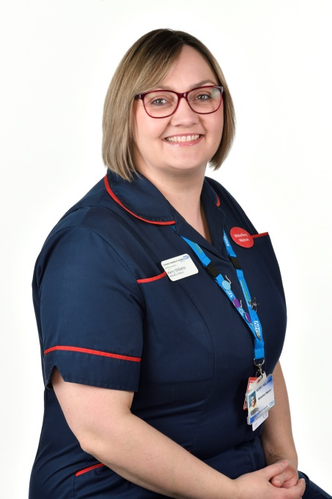

Kerry was appointed as the Deputy Head of Midwifery at University Hospitals of Leicester in September 2020. She has been a midwife for 17 years working predominantly at Leicester Hospitals.

As well as working as a clinical midwife, Kerry was a clinical educator for preceptorship and set up the first newly qualified preceptorship programme which has been running at UHL for over 10 years. She has also worked as a delivery suite coordinator, deputy ward manager as well as leading the intrapartum and inpatient maternity service at both acute units as a matron. Kerry has a passion for staff engagement, organisational culture and patient safety.

Kerry was the local lead on the Maternal and Neonatal Health and Safety Collaborative which contributed to a reduction in brain injuries at UHL using Quality Improvement methodology.