**Lisa Barrott**

**Macmillan Nurse & AHP lead for Cancer, Palliative and End of Life Care**

**University Hospitals NHS Foundation Trust**

**Board Member, UK Chemotherapy Board, UK Oncology Nursing Society Board**

[**lisa.barrott@nhs.net**](mailto:lisa.barrott@nhs.net)

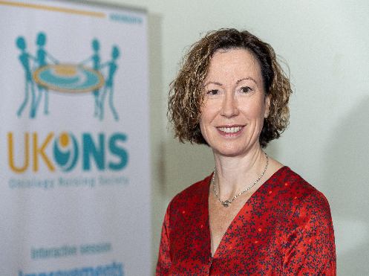

Lisa has had a varied nursing career, working in burns and then general intensive care before moving into oncology approximately 15 years ago. Since moving to cancer care she has worked in a variety of areas, including research, ambulatory care, Acute Oncology and Cancer of Unknown Primary; and has also undertaken different roles including clinical nurse specialist, nurse manager, Cancer Matron and Chemotherapy Nurse Consultant.

Lisa recently moved to University Hospitals Sussex NHS Foundation Trust as the Macmillan Nurse and AHP Lead for Cancer, Palliative and EOLC. She works closely with Cancer Alliances, Commissioning Groups and National charities to develop services locally and nationally.

Lisa is very interested in the development of extended practice roles and innovative, new models of care that allow patients to have their treatments closer to home, outside the hospital setting. She is a strong advocate of nurse education and supporting specialist cancer nurses to meet the challenges they face professionally. She is keen to ensure oncology nurses have a strong voice in shaping policies and services across the four nations through involvement with key organisations and industry. Lisa is currently undertaking a part-time PhD through King’s College London looking at multi-professional SACT clinics.