Biography and abstract  
  
Heather McHugh  
  
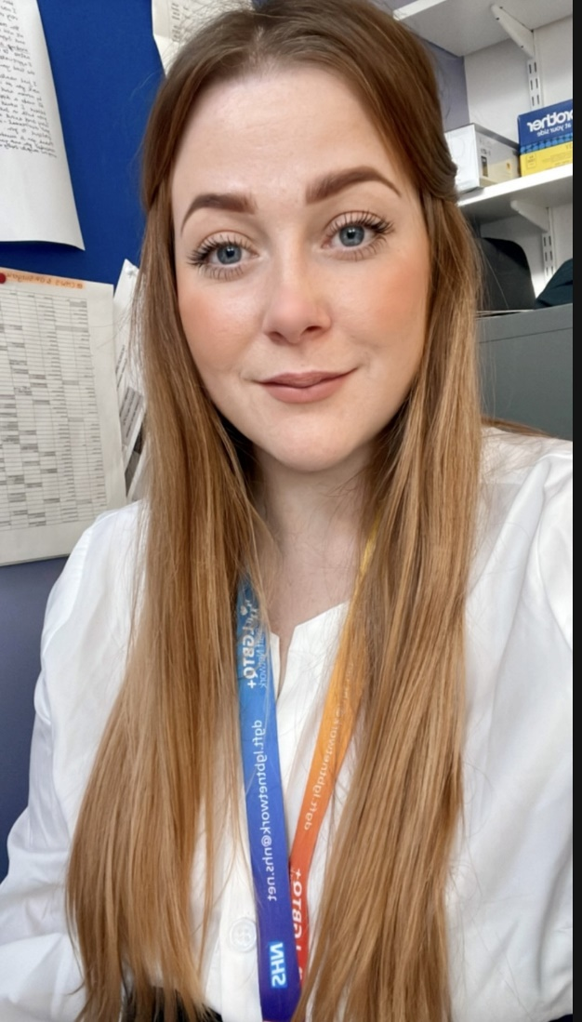

Heather started her career in the NHS in 2012 and qualified as a Midwife in 2016. Heather holds a BSc (hons) in Midwifery, a level 7 in Professional Midwifery Advocacy and is undergoing a Level 7 in social complexities in maternity care. During her midwifery career Heather has been a Specialist Midwife for perinatal mental health, safeguarding, substance misuse and social complexities.  
In February 2023 Heather was appointed as the Equality, Diversity and Inclusion Lead Midwife at Dudley group NHS Foundation Trust. Heather is focusing on making services more inclusive, accessible and promoting an environment that puts the birthing population at forefront of equitable care.