Biography

Elaine A Hanzak B.Ed (Hons)

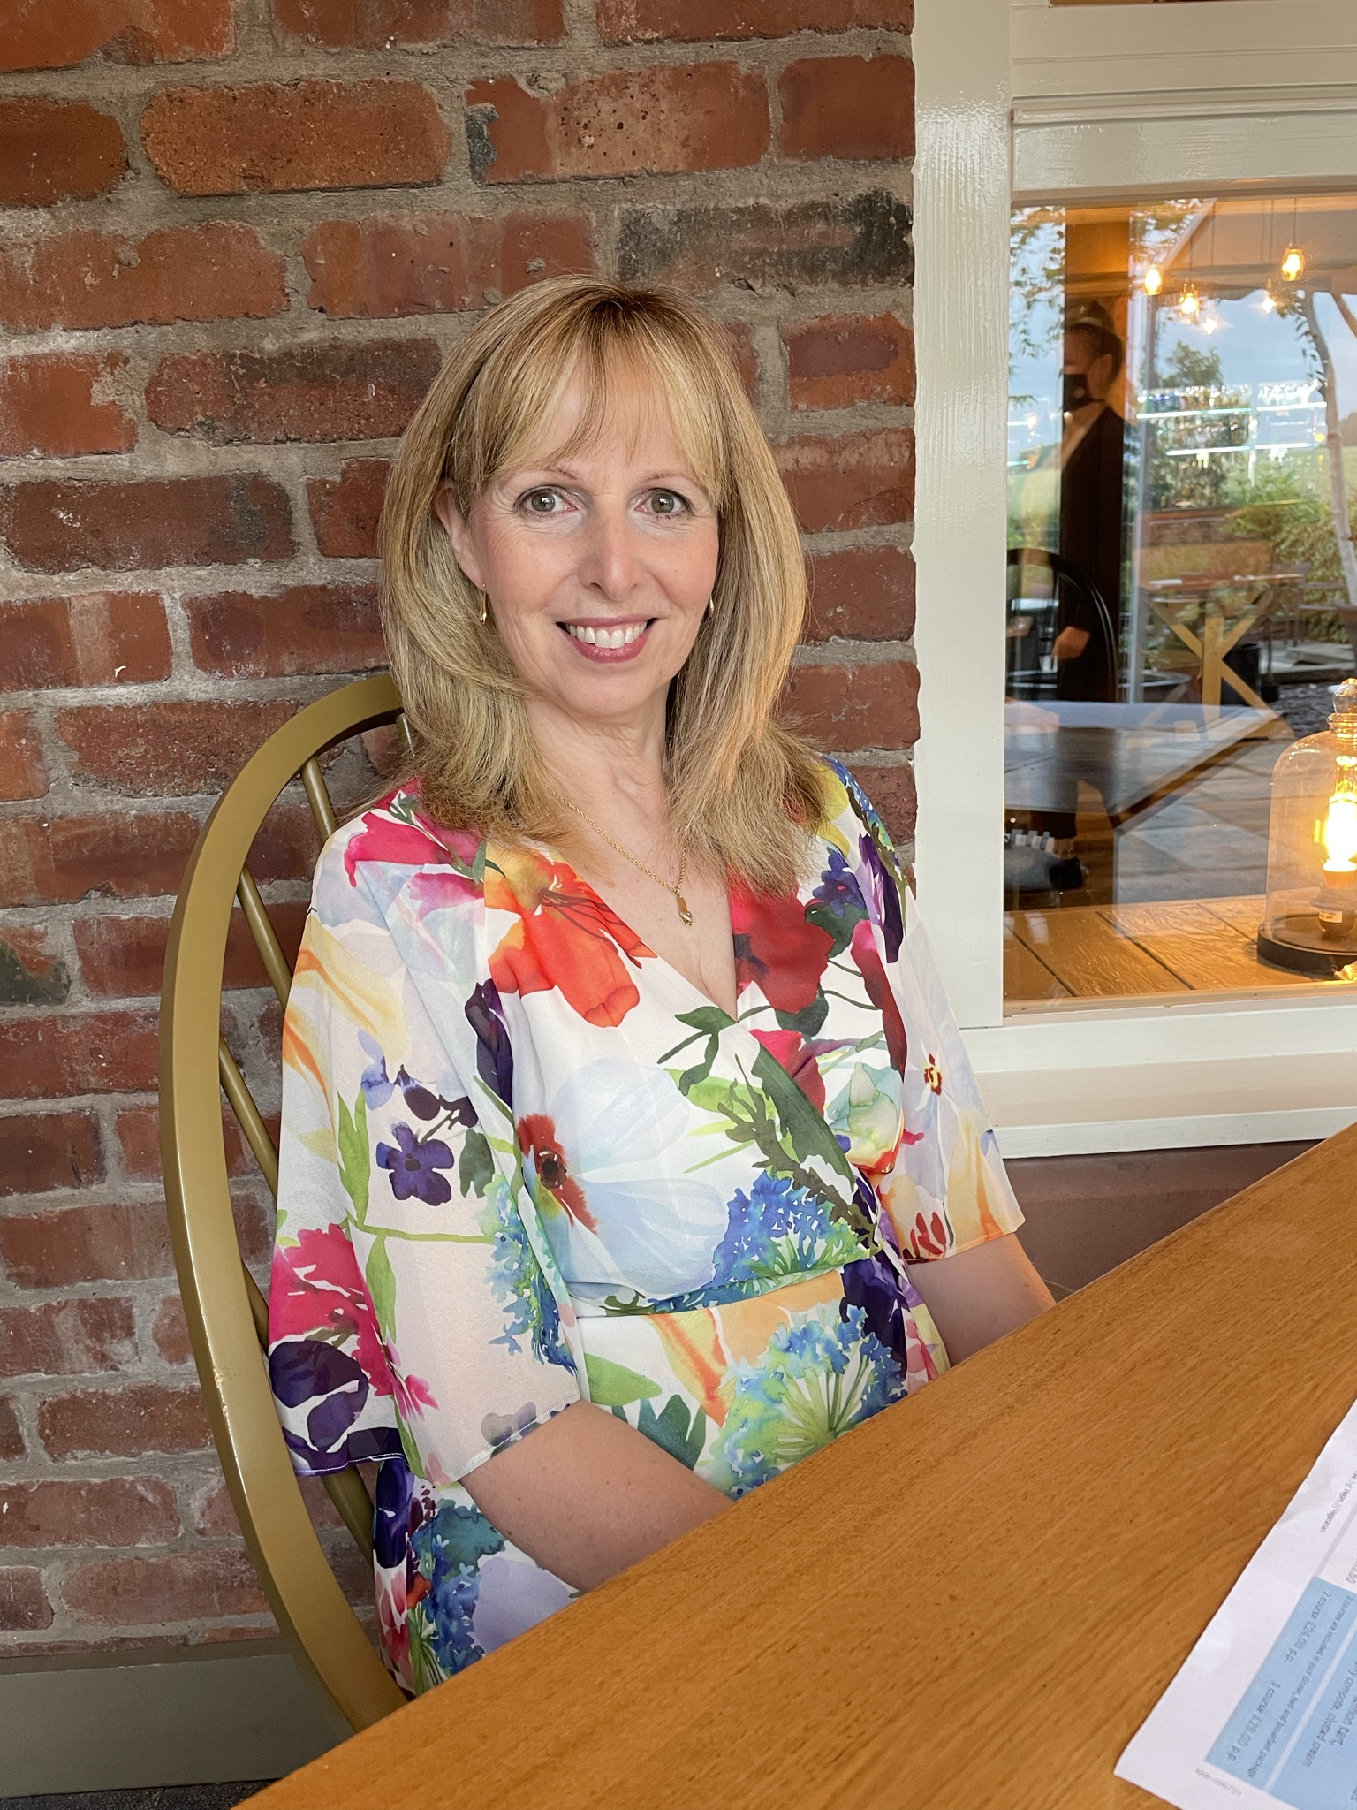
Elaine is a professional speaker, chair, workshop leader and author on perinatal mental health, initially through lived experience and subsequently through gained knowledge. She is also PA to Mike Coote at Mike Coote Coaching.
Originally a teacher for children with severe learning difficulties, she resigned to dedicate herself to the field of perinatal mental health. Her first book, ‘Eyes without sparkle – a journey through postnatal illness’ (2005, CRC Press) describes the story of her spiral into and out of postnatal depression and psychosis following the birth of her son. Elaine has appeared widely on television, radio and in the media and has been working tirelessly to improve awareness and resources for perinatal mental illness for all the family.
Her second book, ‘Another Twinkle in the Eye – contemplating another pregnancy after perinatal mental illness’ (CRC Press, 2015) was shortlisted for the BMA Popular Medicine Book of the Year 2016 for outstanding contribution to medical literature. This is a guide for parents who are considering another baby after a previous perinatal mental illness and ideas for how healthcare professionals can support them. Testimonials report that her first book continues to save lives and the second is helping to create new lives.
She was runner-up in the final of the British Journal of Midwifery Award for ‘Contribution by a non-midwife to midwifery practice’ and nominated as Cheshire Woman of the Year in 2016. In December 2019, just before the pandemic, she was the opening keynote speaker at a prestigious psychiatry conference in the Middle East.
Elaine has experienced COVID-19 followed by months of Long COVID that impacted on both her physical and mental health. It has given her a renewed passion to encourage others and those who support them. In July 2021 she married Mike Coote.
Overall, Elaine’s message is one of hope and encouragement. Audiences comment on her warmth, honesty and humour in her presentations. She aims to inspire the delegates today to support those impacted by perinatal and other mental health challenges to get their sparkle back as she has.
Website: www.hanzak.com Email: elaine@hanzak.com

