Carol King-Stephens
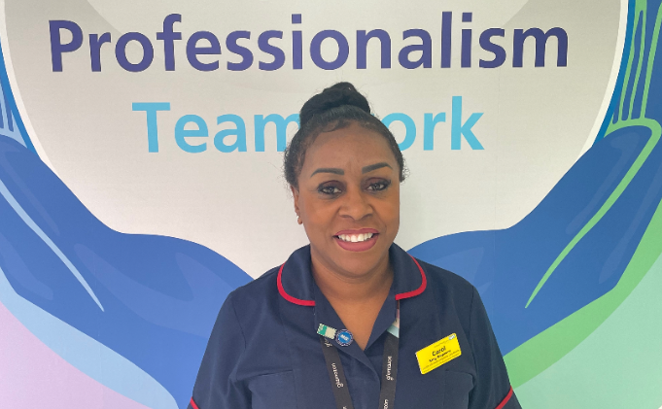
Carol King-Stephens started her NHS career in 1990 she qualified as a Nurse in 1993 and qualifying as a Midwife in 1995. In March 2022 she was appointed as Equality Diversity & Inclusion Lead Midwife at Walsall Healthcare NHS Trust and is focused on making its services more culturally aware and equitable for Black, Asian and Minority Ethnic service users.
“This role is based on research – research that is compelling and that tells a story for all those who turn to us for support and care,” said Carol who has a degree in Health Promotion, is a Cultural Ambassador and is a graduate of Mary Seacole & Midlands Developing Aspirant Leadership Programme.

