Kirsty Fishburn

Mental Health Nurse, Lecturer in Mental Health and Ph.D. Student in Personality Disorder ‘Exploring the lived experience of women’

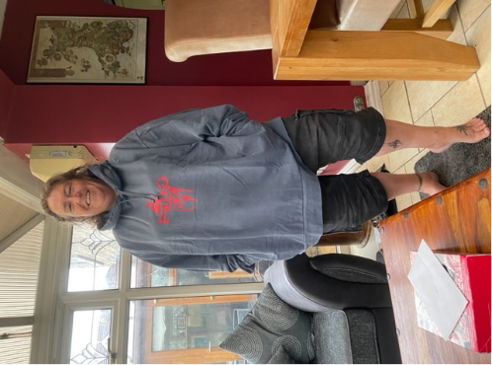

I qualified as a mental health nurse in 2000 after many years of wanting to be the next Indiana Jones. Once I realised this was not a possible career trajectory, largely because hats do not suit me. I still wanted to understand cultures and *people why we are as we are* and *do what we do*. It was suggested to me to work in mental health and train to be a nurse, as that would put me right in the mix of working with people, who are living there lives…. And maybe being able to help them along the way.

Once I started my training I was hooked…. What an amazing insight into human nature and what a tremendous privilege to work with people like these. I realised I couldn’t help everyone, but what I could do was help one person maybe for 5 minutes but that was all that was needed, one person at a time working with me to help them recognise what they could be capable of….. wow!

I seemed to find my home in forensic mental health and secure psychiatry, again I loved it, working with people, who society in some part had given up on. Locked away, to be forgotten.

I started as a Staff Nurse and then worked my way up to Hospital Director over years enjoying roles such as Charge Nurse, Nurse Consultant and Director of Nursing. I completed my MSc in Health Professional Education and decided I wanted a change and hoped maybe some of the knowledge I had gained along the way might be of benefit to people who wanted to work in Healthcare. I joined the University of Hull in 2015 and started my Ph.D. in 2016 (yes nearly there). I now love to teach people who want to know more about working with people and mental health. Everyday is literally a school day!

The rest is history, here I am… looking forward to sharing stories and learning from you too.

More personally, I love horror movies and big hairy spiders… I love to travel with my husband and embarrass the kids when the opportunity arises.

I do look forward to meeting you.

Abstract :

**A lived Experience Perspective - Personality Disorders, Kirsty Fishburn**

This session will look at what is the diagnosis of personality disorder about, who does it help? What do we understand by it? How do we get it? The PowerPoint-based session will ask questions and ask us to reflect on our own perspectives and beliefs about what we know about personality disorders.

How can we acknowledge, recognise and try to reduce the stigma about personality disorders. What do we think of the diagnosis and do we address it and work with people who experience this diagnosis.

What services are needed? What do we have and how do they help? What is a specialist service and how do we best support the people living with this diagnosis?

What does living with this diagnosis look like? Let us challenge the stereotype and see the person.

Please come open minded, with the ability to reflect maybe our own unconscious bias

Thanks

Kirsty