Profile Template
Name: Prasanna Nemichandra De Silva
Job Title: Consultant Old Age Psychiatrist, Honorary Clinical Senior Lecturer
Title: Dr
GMC No: 2940148
Qualifications:
MB, ChB, MRCPsych, B.Med. Biol, PG Cert. Ed.
E mail contact – prasanna.desilva@cntw.nhs.uk
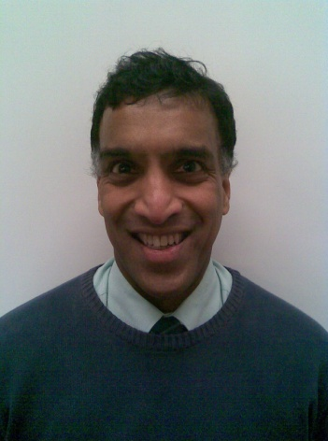
Biography/Professional Background
I am a duel trained adult and old age psychiatrist, post-retirement in 2014 worked part time in Sunderland as a dementia specialist. Just retired (again!) after a 1-year secondment to North Cumbria in Care Home Liaison utilising remote working. In addition, I have worked for University of Sunderland as an Honorary Senior Lecturer (Faculty of Health Sciences) focusing on dementia awareness and remote working practices.
After basic medical training in Aberdeen (1984), I trained in psychiatry at the Royal Cornhill Hospital including research in brain imaging in dementia. Thereafter I completed my specialist training in York, which included experience in Neurology, Geriatrics and Hospice work. Thereafter I moved to Hull as Senior Lecturer (Adult Psychiatry and Rehabilitation) in 1996, before moving to my substantive post in Whitby as Adult and Old age primary care liaison psychiatrist for the next 15 years from 1998, which included 8 years as College Tutor.
I have completed a 2-year secondment as a Specialist Advisor for the Care Quality Commission (CQC) involving 23 full inspections of mental health trusts across England. My primary academic interest is in Neuroinflammation; how immune processes affect psychiatric syndromes such as psychosis, depression, dementia, and delirium. I have been a Cochrane Collaborator. On life outside medicine, I play ‘cello for Sunderland Symphony Orchestra and enjoy touring the highlands in my MX5.
Relevant publications
- De Silva, P.N. Avoiding bias: the key to good leadership in psychiatric practice? Progress in Neurology and Psychiatry, Vol.13, Issue 6, Jan 2010
- De Silva, P.N., Hobkirk, M., Pragmatic leadership in teams and groups Module RCPsych eCPD Programme, Jan 2015
- De Silva, P.N. Triage portals into A&E departments. Emergency Medical Journal, 2020 (e letter) https://emj.bmj.com/content/37/8/458
- De Silva, P.N. options for remote working post Covid19 eCPD Module RCPsych Feb 2022
- De Silva, P.N. New Ways of Working 2.0 to accommodate transformation, integration, and net zero. iMind General Adult Faculty Newsletter. Feb 2023: 40 – 46

Specialty | Hospital Base
Geriatric Psychiatry | Monkwearmouth Hospital, Newcastle Road, Sunderland. SR1 2AT
Contact e mail
Prasanna.desilva@cntw.nhs.uk

