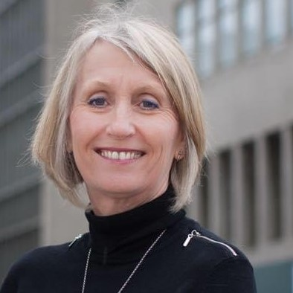
Jude Diggins
RGN RSCN MSC LLM
Lead Freedom to Speak Up Guardian
Southern Health NHS Foundation Trust
Jude has been a Registered Nurse for over 30 years. She has worked in most settings including acute, community, tertiary paediatric, mental health and learning disability provider settings in the UK and Ireland. She has worked from ward to board. In late 2014 Jude left the NHS and embarked on a full time Master of Laws programme qualifying with distinction in 2016, her dissertation focused on employment law.
She worked at the Royal College of Nursing from 2016 to 2021 in a variety of roles including Regional Director for London and acted as UK Director of Nursing, Employment Relations and Public Affairs for most of 2021.
Jude became a Freedom to Speak up Guardian in January 2022 and has worked hard to debunk and demystify speaking up – to promote the benefits to staff; service users and the organisation. Jude believes passionately in open and honest cultures and particularly in compassionate leadership having seen the extraordinary benefits to all when just and compassionate cultures prevail.
As a senior and experienced leader Jude was attracted to the Guardian role as a positive for cultural change. In her role at the RCN she saw the impact of poor cultures on staff and ultimately patients; but also saw how easily so many difficult situations could have been averted if team cultures were better and speaking up was business as usual. Jude has a reputation for being a compassionate and inclusive leader.

