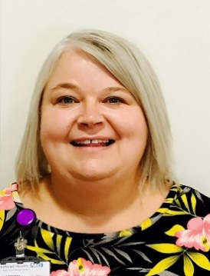

I joined CDDFT in 2019 after over a decade at Gateshead NHS Foundation Trust where I held a number of managerial positions overseeing operational functions. I worked within Workforce Services, Health Records, Screening Services and finally joining Corporate Services in 2015. Late to academia I graduated with a degree in Ba Hons in Applied Management in 2016 from Sunderland University and have also successfully achieved a Masters in Business Administration this year from Teesside University.

After a spell as Safeguard Lead for Patient Safety I opted for a new challenge at CDDFT where I firstly become a Patient Safety Manager and now Patient Experience Manger. I have a passion for patient care excellence and strive to learn from our incidents and complaints to enhance the patient experience. A large part of my role is service improvement and project facilitation working with our clinical teams.

I strive to champion our volunteer service here at CDDFT and understand how the service compliments our patient experience, assist clinical staff. I actively recruit volunteers to assist our clinical teams but also to offer opportunities to volunteer’s to gain employment should they wish to.