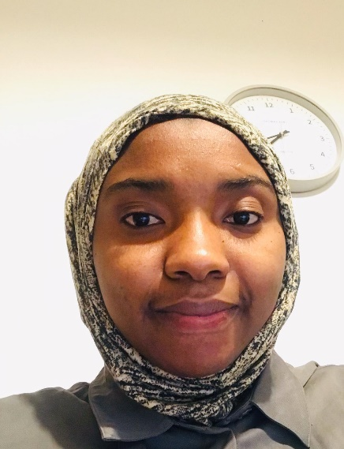
Zenab Barry, Director at National Maternity Voices Council

Zenab Barry is a Political Scientist and an International Development Specialist. She co-chaired Chelsea and Westminster Maternity Voices Partnership until March 2022 and was Chair of Council at National Maternity Voices until November 2022.

She is passionate about research in the maternity realm; and has particularly been focusing on studies that address maternal inequities and inequalities. To that effect, Zenab has actively taken part in a range of research projects at King's College London (including being a PPIE member at ARC South London) and various other academic institutions.

