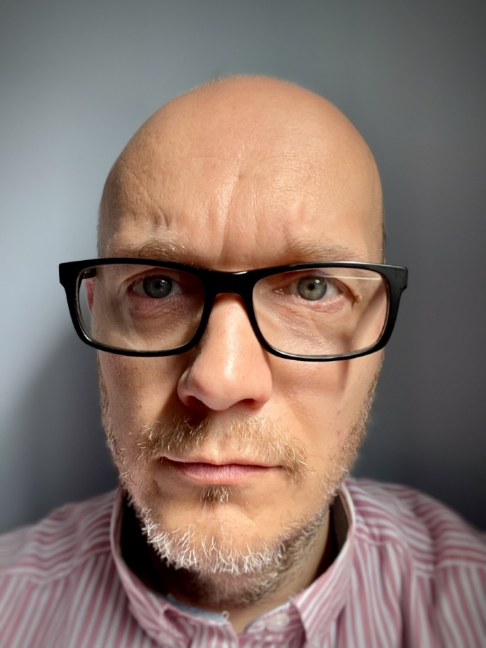

Paul Mooney BSc(Hons); MSc; CPsychol(Foren); AFBPsS; CSCi

Paul is Clinical Director for Elysium Neurological and holds positions as Assistant Professor with the School of Medicine, University of Nottingham and Visiting Fellow with the School of Psychology, University of Lincoln. He is a peer reviewer for a number of journals, and also lectures and supports students on Doctoral and other postgraduate courses.

His role is varied and includes supporting service development and improvement of Neurological hospitals and care centres across the country.

He has experience working with people with a variety of presentations across different care settings, as well supporting the development of new services. Paul is an advocate for formulation-led, person-centred care and has interests in behaviour support and executive dysfunction.

He has a background in research, with a number of peer reviewed publications on a variety of subject areas including the assessment and management of people with neurodevelopmental disorder and offending behaviour; Personality Disorder & Psychopathy; risk assessment in neurological and neurodevelopmental populations; social climate and culture; and sexual behaviour & offending.